Creamos un objeto para estandarizar

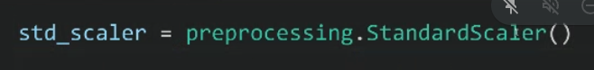

No hemos dividido en train y test





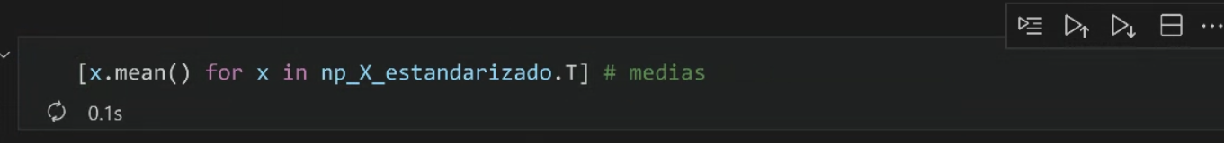



Transponemos la matriz y las columnas pasan a ser filas

List comprehesion para generar la media de las columnas

